|  |
| --- |
|  |

**SAMA: Software Requirements and Design**

In the next section, we will discuss the functional, non-functional, software, and hardware requirements, as well as the use case diagram and description. These requirements define what the application should do and the way it should function. In the use case diagram, the interaction between the user and the application is shown in its simplest form. We defined use case descriptions to describe how the user will accomplish specific tasks and to see how the system will respond from the user's perspective.

**Functional Requirements**

FR 1: Registration

FR 1.1 The user shall sign up using his/her name, username, email, phone number, and password.

FR 2: Login

FR 2.1 The user shall log in using his/her username and password.

FR 2.2 The system shall show the option (“forgot password”) in case the user forgot it and want to reset it.

FR 2.2.1 The user shall reset the password using the phone number.

FR 2.2.2 The system shall send the OTP code to the user’s phone number in less than 20 seconds.

FR 2.2.3 The system shall allow the user to reset the password once the OTP is correct.

FR 2.3 The system shall keep the users logged in unless they logged out manually from the profile page.

FR 3: Choosing interest:

FR 3.1 The system shall allow the user to choose the goals he/she is interested in.

FR 3.2 The user can either choose his/her interests at the beginning or later from the 17 goals page.

FR 3.3 The system shall allow the user to change his interests from the 17 goals page by pressing the edit button.

FR 4: Profile update:

FR4.1 The system shall allow the user to change his information (name, email, phone number, password).

FR 4.2 The system shall allow the user to upload/ change the profile photo from the profile setting page.

FR 4.3 The system shall allow the user to log out from the profile page.

FR 5: Notifications:

FR 5.1 The application shall send a notification to the user (in case notifications were enabled) if someone liked/disliked his/her post.

FR 6: Goals page

FR 6.1 The system shall show the 17 goals icons on the 17 goals page.

FR 6.2 The user shall click on each goal icon to know more about it.  
FR 6.2.1 The system shall show the goal name, description, actions, and related posts

FR 7: Posting

FR 7.1 The system shall allow the user to post/upload a photo of an action he/she did.

FR 7.1.1 The user shall choose the goal and the action he/she is participating in.

FR 7.1.2 The user shall write a short description of the post.

FR 7.1.3 The user shall choose to share this post publicly or privately.

FR 8: Points

FR 8.1 The system shall assign points for every new post the user shares.

FR 8.2 The system shall increase the post’s points with every new like.

FR 8.3 The system shall show the total points for each user as a score on his/her profile page.

FR 9: Likes/dislike

FR 9.1 The system shall allow the user to like/dislike others’ posts.

FR 10: Ranking Page

FR 10.1 The system shall show the top 10 users with the highest scores on the ranking page.

FR 10.2 The system shall update the ranking page list every 24 hours.

FR 11: Profile Page

FR 11.1 The system shall show the username, profile photo, user’s total posts, user’s Score, and posts’ photos on the user’s profile page

FR 12: Search

FR 12.1 The application shall allow the user to search for posts related to a certain goal or username through the search page.

FR 13: UAE Contribution

FR 13.1 The system shall redirect the user to the official Twitter account related to SDGs in UAE “@UAESDGs”

**3.1.2 Non-Functional Requirements**

NFR1. Usability requirement

NFR1.1. The application shall be easy to use and self-explanatory for users who use smartphone apps. Users shall be familiar with the application in a maximum of 1 day.

NFR1.2. The system assumes that all its users have basic knowledge of the English language.

NFR1.3. The system shall work efficiently on Android system phones.

NFR2. Reliability requirements

NFR2.1. The system shall be available 24/7 hours.

NFR2.2. The system shall respond by using verification within 5 seconds, and the maximum response time should be 10 seconds.

NFR3. Security requirement

NFR 3.1. The system shall encrypt the user's personal information and decrypt it for system uses only. No one else can access the system.

**3.1.3 Software Development Requirements**

SDR1. The application shall be developed in Android Studio (version 2021.2.1 patch 2).

SDR2. The application shall be developed using the object-oriented methodology.

SDR3. The application shall be developed using the Java programming language.

SDR4. The application shall use Google Firebase for NoSQL database storage.

**3.1.4 Hardware Requirements**

HR1. The system assumes that all its users have internet access.

HR2. The application requires an Android device with an API of level 30 or higher.

**3.1.5 Use Case Diagram**

Figure 2 presents the use case model of our application. The stickman notation represents actors. Actors are external entities that interact with Terra. We have 3 actors, namely, users, firebase DB, and 3rd partners. These actors interact with Terra in different functions, modeled in ovel notation in Figure 2.

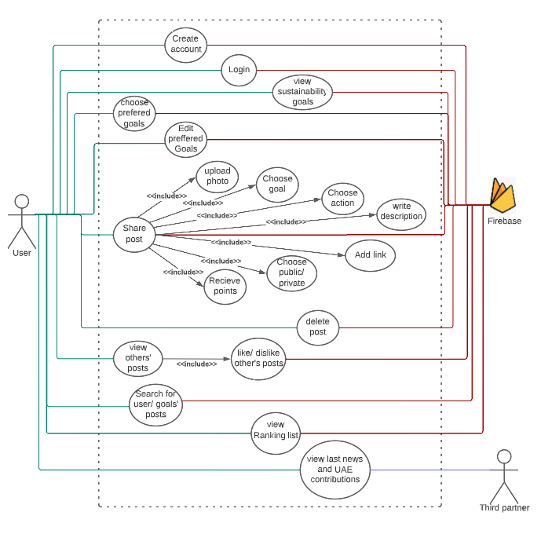

**Figure 2. Use case diagram**

* **Use case description**

In the following table, we present a detailed specification of each use case modeled in Figure 2

**Table 3. Use case 1 description**

|  |  |
| --- | --- |
| Use Case | UC1. Create an account |
| Actor(s) | User |
| Precondition | User launched the application for the first time. |
| Postcondition | User creates an account. |
| Basic Path | 1. The user chooses to create an account. 2. The application asks the user to enter registration details (name, username, phone, email, and password). 3. The user clicks on the “create account” button. 4. The new user is registered in the system. |
| Alternative Paths | A1. Invalid username/ phone number/email  3.1 The application shows a message that the username/ phone number/ email is  invalid.  3.2 Go to step 2. |

**Table 4. Use case 2 description**

|  |  |
| --- | --- |
| Use Case | UC2. User Login |
| Actor(s) | User |
| Precondition | User should have an account. |
| Postcondition | The system will allow the user to access the application after checking login information. |
| Basic Path | 1. The user chooses login. 2. The application asks the user to enter his username and password. 3. The user clicks on the “log in” button. |
| Alternative Paths | A1. Invalid Login  3.1 The application shows a message that the login information is invalid.  3.2 Go to step 2. |

**Table 5. Use case 3 description**

|  |  |
| --- | --- |
| Use Case | UC3. Choose preferred goals |
| Actor(s) | User |
| Precondition | User registered successfully. |
| Postcondition | The user chooses a preferred goal. |
| Basic Path | 1. The user chooses goals he/she is interested in. 2. The user clicks on “next” after choosing goals. 3. The user can click “skip” without choosing any goal. |

**Table 6. Use case 4 description**

|  |  |
| --- | --- |
| Use Case | UC4. View sustainability goals |
| Actor(s) | User |
| Precondition | User clicks on the 17-goal icon on the home page. |
| Postcondition | User viewing one of the 17 sustainable goals. |
| Basic Path | 1. The application shows all 17 goals. 2. The user clicks on one of the goals to know more about it. 3. User clicks on “edit” to add/remove any preferred goal. |

**Table 7. Use case 5 description**

|  |  |
| --- | --- |
| Use Case | UC5. Share post |
| Actor(s) | User |
| Precondition | User clicks on “add post”. |
| Postcondition | User shared a post. |
| Basic Path | 1. The user takes/uploads a photo 2. The user can retake and upload a new photo 3. The user clicks on “Next” 4. The user writes description 5. The user chooses a goal 6. The user chooses an action 7. The user adds a link (optional) 8. The user chooses to share it publicly/privately 9. The user clicks share 10. The user receives points |

**Table 8. Use case 6 description**

|  |  |
| --- | --- |
| Use Case | UC6. Delete posts |
| Actor(s) | User |
| Precondition | Choose a post. |
| Postcondition | User deleted a post. |
| Basic Path | 1. The user goes to the profile page. 2. The user clicks on a certain post. 3. The user clicks on the delete post option 4. The users can delete the post even from the homepage. |

**Table 9. Use case 7 description**

|  |  |
| --- | --- |
| Use Case | UC7. View others’ posts |
| Actor(s) | User |
| Precondition | The application shows the home page. |
| Postcondition | User can like/dislike posts. |
| Basic Path | 1. The user scrolls through the home page. 2. The user views others’ posts. 3. The user taps on the like or dislikes button (optional). |

**Table 10. Use case 8 description**

|  |  |
| --- | --- |
| Use Case | UC8. Search for users/posts |
| Actor(s) | User |
| Precondition | User clicks on the search button. |
| Postcondition | List of posts/users will be shown. |
| Basic Path | 1. The user types the username or chooses the goal they want to view. 2. The results will be shown. |

**Table 11. Use case 9 description**

|  |  |
| --- | --- |
| Use Case | UC9. View ranking list |
| Actor(s) | User |
| Precondition | User clicks on the ranking list button on the home page. |
| Postcondition | List of the top 10 users is shown |
| Basic Path | 1. The user chooses to view the last 24 hours list. 2. The top 10 users with the highest scores will be shown. |

**Table 12. Use case 10 description**

|  |  |
| --- | --- |
| Use Case | UC10. View the latest news and UAE contributions |
| Actor(s) | User |
| Precondition | User clicks on the UAE icon. |
| Postcondition | Users view tweets related to UAE contributions in SDGs. |
| Basic Path | 1. The system redirects the user to the “@uaesdgs” Twitter account. |

## 3.2 Design Setup

To successfully run our application, it shall be installed on an Android smartphone with API 31 or higher. And it should be connected to the internet to allow the app to access the Cloud DB (Google Firebase).

## 3.4 Tools and methods

**3.4.1 Android studio**

Our application has been developed using Android studio which is the official Integrated Development Environment (IDE) for Android app development. We chose it because it has a great set of tools and plugins. Using this environment, we created the XML files which represent the front end of our application. The classes and functions were implemented using java activity pages.

**3.4.2 Google Firebase**

Many services from Google Firebase were used to manage the application. To begin with, the authentication service was used to send confirmation codes to the user whenever he/she wanted to change/ reset his/her password. Also, to store static data that rarely changes such as goals’ descriptions, actions under each goal, and initial points for each action, we used the Firestore Database service. Moreover, Firebase Realtime Database service was used to store frequently updated data like posts, the number of likes/dislikes, points for each post, and the user’s score.

|  |
| --- |
|  **Figure 3. System Architecture** |
|  |

## 3.5 System Architecture

The architecture of the developed system is shown in Figure 3. The system components in this system are users, smartphones, java pages, Terra application, internet connection, and Firebase.

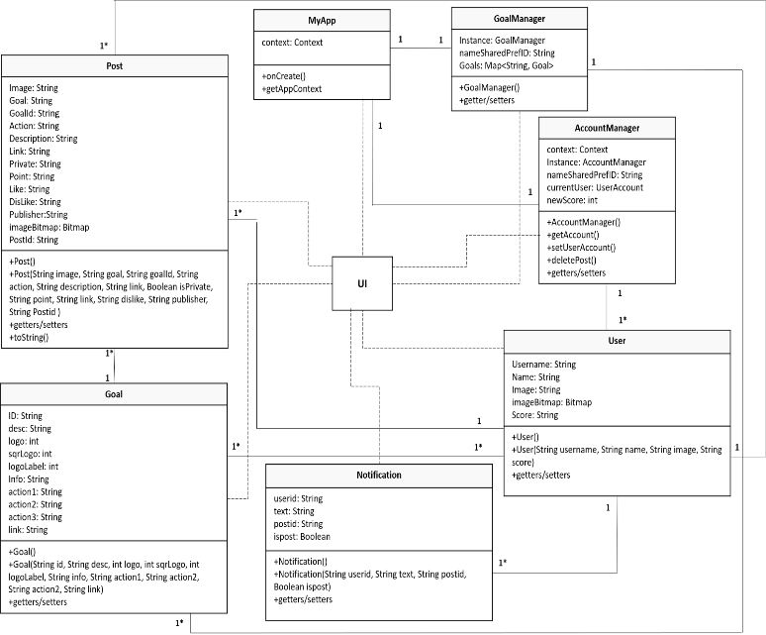**3.5.1 Class diagram**

Figure 4 shows the classes that we are going to create along with the relationship between them and there is a detailed description for every class shown in table 13.

**Figure 4. Class diagram**

**Table 13. Class diagram description**

|  |  |
| --- | --- |
| **Classes** | **Description** |
| **User** | A class will hold the object User that contains the user’s information as attributes such as username, name, Image, imageBitmap and score. It will have constructor, getters, and setters as functions to retrieve user information. |
| **Post** | A class that will hold the object Post that contains the post information as attributes such as image, goal, goalid, action, description, link, private, point, like, dislike, publisher, imagebitmap and postid. It will have constructor, getters, and setters as functions to retrieve post information, as well as toString method to print the attributes. |
| **Goal** | A class will hold the object Goal that contains the Goal information as attributes such as goalID,description, logo, sqrlogo, logolabel, info, action1, action2, action3, and link. It will have constructor, getters, and setters as functions to retrieve goal information. |
| **Notification** | A class will hold the object Notification that contains the Notification information as attributes such as userid, text, postid, and ispost. It will have constructor, getters, and setters as functions to retrieve notification information. |
| **MyApp** | A class will hold the context of the application, this class will be linked with AccountManager and GoalManager to provide the application context since they are java classes and not an activity, so they contain the application context. |
| **AccountManager** | A class will help with holding the current user information and sharing it between the activities such as username, name, score, and profile image. |
| **GoalManager** | A class will hold the goal object information such as goal id, goal name, goal icons, goal info, actions, and link and share it between the classes. |
| **UI** | The user interface will combine all the classes' functions in a user-friendly interface that is easy to use. |

**3.5.2 Activity diagram**

Figure 5 shows the workflow of the app where the rectangles are the actions, the arrow shows the next action, the diamonds are for merging or decisions, and the circles show the start point and the endpoint.

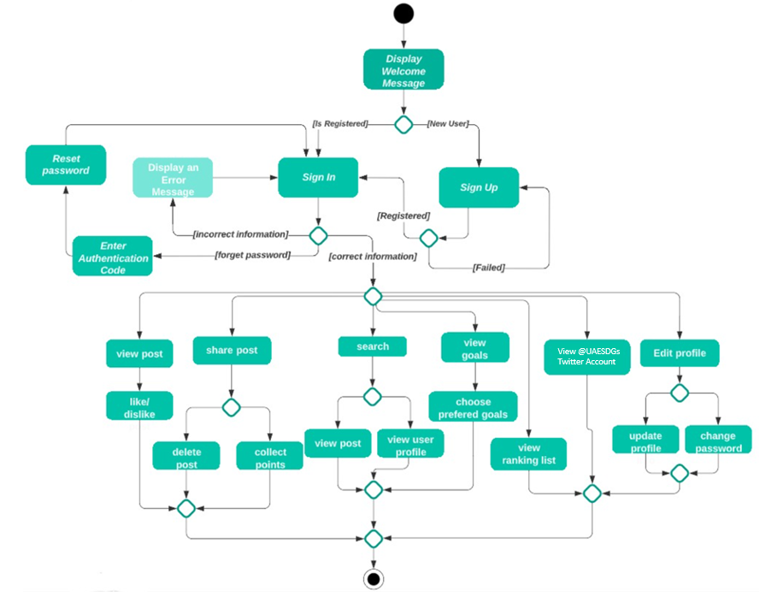

**Figure 5. Activity diagram**

**3.5.3 Data architecture**

We are going to use the Google Firebase platform that will help us to build our project in high quality.

**I.** **Cloud Firestore**

Cloud Firestore saves the information in the form of a collection of documents [9]. It will be used in the application to store data such as goals, actions and points that are infrequently changed. We have one collection (Goals) filled with 17 documents which are the 17 goals and each document contains three fields which are the action and their points actions. Shown in figure 6.

**II.** **Real-time database**

The data is stored as a single large JSON tree structure [6], which is updated regularly. We will use two structures in this project to retrieve the data as quickly as possible. We will have multiple users in the first structure. Each user will have posts, score, email, profile photo, phone number, username, name, password, interests and notifications. Under the notifications, there will be isPost, post id, text and user id. Under the posts there will be all the user posts with a unique ID. Each post will contain action, description, goal, goal id, image, likes, dislikes, points, post id, private, and publisher. Shown in figure7.

|  |  |
| --- | --- |
|   Figure 6. Cloud Firestore |   Figure 7. Real-time database |

## 

## Testing

For testing our application, the black-box methodology was used which allows testing the application functionality from the user perspective without going into the details of the application such as the code, structure, development method, etc. Table 15 shows the testing scenarios, input, expected result, and result.

**Table 15. Testing Plan**

|  |  |  |  |  |
| --- | --- | --- | --- | --- |
| **No** | **Scenario** | **Data value** | **Expected result** | **Result (SF)** |
| **1** | Choose interests | The user selects the preferred goals. | Home page | Succeed |
| The user doesn't select the preferred goals. | Home page | Succeed |
| **2** | Users view the 17 goals | The user taps on the 17 goals button on the upper bar of the home page. | 17 goals listed as buttons | Succeed |
| **3** | User view UAE contributions related to SDGs. | The user presses the UAE contributions button on the upper bar of the home page | Redirect the user to the “@UAESDGs” account on Twitter. | Succeed |
| **4** | User view ranking list | The user presses on the ranking list button on the upper bar of the home page | List the top ten scores of the last 24 hours of the users. | Succeed |
| **5** | User view post | The user taps on the like icon under the photo. | Increase the number of likes, points received, and post owner score. | Succeed |
| The user presses on the dislike icon under the photo. | Increase the number of dislikes. | Succeed |
| **6** | User search for a post/ other users | The user presses the search button on the home page, chooses search by goal name, and chooses a goal name from the scroll view. | Show posts related to the selected goal. | Succeed |
| The user presses the search button on the home page, choose search by username, and type a username in the search bar. | Show a list of users with similar usernames. | Succeed |
| **7** | Notifications | The user presses on the notification button | List notifications for the last likes/dislikes received. | Succeed |
| **8** | Profile page | The user presses on the profile button | Display user’s profile image, name, username, number of posts, score, and posts. | Succeed |
| **9** | Take/upload photo | The user presses the share button and takes/uploads a photo. | Display the taken/uploaded photo | Succeed |
| **10** | Share a post | The user enters the post details: (goal name, action name, description, link (optional), private/public.) | Upload the post, the user gets initial points, and the user's score increases. | Succeed |
| **11** | Delete a post | The user presses the three dots under his post and chooses to delete the post. | Display a confirmation message: “Are you sure you want to delete this post? ” | Succeed |
| **12** | Edit preferred goals | The user presses the edit button on the goal page. | Display a checkbox next to each goal. | Succeed |
| **13** | Display a goal | The user presses on one of the goals from the goals page | → Goal’s page | Succeed |
| **14** | Display Actions related to a goal | The user presses on “Actions” on a goal page. | Display information and actions related to the goal. | Succeed |
| **15** | Display posts related to a goal | The user presses on related posts on a goal page. | Display posts related to the goal. | Succeed |

Other detailed test cases in Appendix C: Test Cases scenarios

* **Testing tools:**

To test the application, two android devices of type Samsung Galaxy J4 SM-J400F have been used. In each device, a different user was logged in to test all possible scenarios of interactions between two users.

## 4.3 Analysis of Results

**Figure 8. User Interface**

Figure 8 shows the user interface of the project. a detailed description of every screen shown in table 16.

**Table 16. User interface design description**

|  |  |
| --- | --- |
| **Screen number** | **Description** |
| Screen 1 | User selects his interest goal from the 17 goals. |
| Screen 2 | The main page of the user. |
| Screen 3 | The page of all goals with user-selected interests is on the top. |
| Screen 4 | The page of a certain goal with a description, access to all posts related to this goal, and actions to do with this goal. |
| Screen 5 | The related post to goal 1. |
| Screen 6 | The page shows the latest UAE contribution in the sustainability field and activities. |
| Screen 7 | New post page where the user can write the description and choose the goal and action. |
| Screen 8 | A page that shows a notification when users interact with each other’s. |
| Screen 9 | Profile of the user displaying posts and scores. |
| Screen 10 | Search page with the option to search by a goal to see related posts. |
| Screen 11 | Search page with the option to search by users to view users’ profile |
| Screen 12 | Viewing another user profile. |
| Screen 13 | Posting page where the user can take a picture or upload his action. |
| Screen 14 | Ranking page of all users displaying results every 24 hours and a week. |

The login screens and other detailed screens are in Appendix D: User interface

## 4.4 Potential Improvements

Although the project has been completed, we still have many ideas to improve it in the future. For example, adding the upload videos option beside photos would make it more interactive and enjoyable. Also, we plan to design another interface for the children to enhance their role in contributing to the field of sustainability. Moreover, adding, creating groups feature gives the opportunity for the users to choose a certain goal and compete among themselves to achieve it, this function will be useful too if the school teachers used it to encourage their students to participate in it.

# References

[1] "Sustainable Development Definition: Historical Background and Examples", *Youmatter*, 2022. [Online]. Available: <https://youmatter.world/en/definition/definitions-sustainable-development-sustainability/> . [Accessed: 25- Apr- 2022].

[2] "Gamification principles for user engagement - Datagame", *Datagame*, 2022. [Online]. Available: <https://datagame.io/gamification-principles/> . [Accessed: 25- Apr- 2022].

[3] "Sustainability Development Goals | About The Ministry | UAE Ministry of Climate Change and Environment", *Moccae.gov.ae*, 2022. [Online]. Available: <https://www.moccae.gov.ae/en/about-ministry/about-the-ministry/sustainability-development-goals.aspx> . [Accessed: 25- Apr- 2022].

[4] L. Serges, "Top 10 Mobile Apps That Promote Sustainability", *Blog.hylamobile.com*, 2021. [Online]. Available: <https://blog.hylamobile.com/top-10-mobile-apps-that-promote-sustainability> . [Accessed: 25- Apr- 2022].

[5] "Top 10 apps for sustainable living", *Activesustainability.com*, 2022. [Online]. Available: <https://www.activesustainability.com/sustainable-life/top-10-apps-for-sustainable-living/?_adin=02021864894> . [Accessed: 25- Apr- 2022].

[6] J. Carrara, "The Best Sustainability Apps | Eco-Age", *Eco-Age*, 2022. [Online]. Available: <https://eco-age.com/resources/best-sustainability-apps/> . [Accessed: 25- Apr- 2022].

[7] "SDGs in Action", *Sdgsinaction.com*, 2020. [Online]. Available: <https://sdgsinaction.com/> . [Accessed: 25- Apr- 2022].

[8] "Secure data access for users and groups | Firebase Documentation", Firebase, 2022. [Online]. Available: <https://firebase.google.com/docs/firestore/solutions/role-based-access>. [Accessed: 01- May- 2022].

[9] "Firebase | Firestore vs. Realtime Database - Javatpoint", *www.javatpoint.com*. [Online]. Available: <https://www.javatpoint.com/firebase-firestore-vs-realtime-database> . [Accessed: 25- Apr- 2022

1. **Biography**

**Shamma Alkaabi** is a computer science student at UAEU who has a passion for coding which led her to learn 3 coding languages, java, python, and R. During her academic journey she developed many programs for the users such as a patient appointment system and ”Greeno” an application for kids to help them in recycling and reusing. she was a leader for CITA volunteering team for 2 years. She earned many skills during her university life to go out and accomplish achievements contributing to the UAE. She thinks that in this era technology is widespread and that the future is related to technology and robotics, so she entered this specialty and became interested in robotics and hopes to contribute to the development of robots to facilitate life.

**Aisha Almusalami** is a computer science student interested in software engineering, machine learning, UX and UI design, coding, AI, and robotics. In her educational journey, she learned java and python programming languages. Some of her projects included "Turbo Delivery," a web application that enabled customers to order from nearby food stores/ restaurants and allows delivery by couriers. In addition, she worked on an AR application "chemo" which is an android application that uses augmented reality to assist mid-level students in learning chemical elements and compounds. She has been a fellow in the Arab Youth Technology Fellowship program which was organized by the Arab Youth Center. she worked in organizing workshops for the Student Success Unit in UAEU. Recently, she worked on a research paper (A User-Friendly Tool for Estimating Housing Affordability in Abu Dhabi). Currently, she is working on SURE+ research project on ML model to predict fake reviews.

**Fatema Alnaqbi** is a bachelor's degree student in computer science at UAE University, who has a passion for learning new trending topics related to technology and innovations, she is interested in developing web applications, UI and UX design, coding in both languages java and python. During her educational journey, she worked on different projects one of them "Chemo" project, it is an android application that uses AR to assist students to learn chemical elements and compounds. She built a cooperative game to raise awareness about obesity amongst children in UAE using Unity and Blender software. She worked on a research project about "EEG Based game for reinforcing obesity awareness amongst children in UAE", the paper was published at SpringerLink. Participated in the "Machine learning for all" workshop at Expo 2020 and participated in UAE University Annual Research & Innovation and 15th International Conference on human-centered Intelligent Systems. She has been a fellow in the Arab Youth Technology Fellowship program which was organized by the Arab Youth Center. She is looking to improve her skills and experiences in data science and NLP.

**Roqyah Alzeyoudi** is a computer science student, she is currently a student in UAEU and expected to graduate in Fall 2023, she’s a vice president of CITA Club In the year 2021/2022 and was a general secretary of well-being society, Rouqyah loves teamwork and group project as she finds collaborating makes the work perfect. She is passionate to volunteer as she already completed 130 hours of volunteering and is willing to volunteer more, she worked on many projects in the IT field such as “Greeno'' application on android studio and the circus event manager website on Java, she got many skills such as graphic design, programming using java and python, using many useful websites such as Miro, Google collab and Figma for prototyping. She also participated in the Think science contest with the “intelligent walker” project and participated in Innovation week UAE university. She is looking forward to improving her skills in coding, gaming, designing, and learning more in the data mining and analytics field.

**Appendix**

**Appendix A - Goals and actions**

Table 21 shows all the 17 sustainability goals with the created actions for each goal along with the earned point for each action.

**Table 21. Goals and actions**

|  |  |
| --- | --- |
| **Goal ID** | **Actions and points** |
| 1. No Poverty | ● Clothes donation (50)  ● Money donation (50)  ● Toy donation (25) |
| 1. Zero Hunger | ● Donate a meal (10)  ● Give away the extra food (10)  ● Buy organic food or products (30) |
| 1. Good Health and Well-being | ● Walk for 60 minutes (60)  ● Stop fast food for one week (90)  ● Mental health - Meditate, talk to friends or visit (25) |
| 1. Quality Education | ● Volunteer for opening an online session to teach students from other countries (95)  ● Donate used or old laptop that are able to be used (80)  ● Donate books (15) |
| 1. Gender Equality | ● Watch videos about gender equality + write a summary (30)  ● Share a video link about gender equality (30)  ● Attend a lecture about gender equality (75) |
| 1. Clean Water and Sanitation | ● Donate to build water well (50)  ● Donate with 10 bottles of clean water (25)  ● Watch an awareness video on the issue of water pollution (30). |
| 1. Affordable and Clean Energy | ● Turn off lights you don't need (5)  ● Change one old energy consuming product with more efficient and eco-friendly one (90)  ● Use solar energy (70) |
| 1. Decent Work and Economic Growth | ● Read articles about this topic + write summary (30)  ● Support local business (60)  ● Buy local products (70) |
| 1. Industry, Innovation and Infrastructure | ● Read articles about this topic + summary (30)  ● Share your own innovations + innovator's achievements (100)  ● Attend innovation event/workshop (75) |
| 1. Reduced Inequalities | ● Watch a video about reducing inequalities and share it (30)  ● Read article/Book about this topic + summary (30)  ● Attend a lecture about reduce inequalities (75) |
| 1. Sustainable Cities and Communities | ● Walk instead of using a car (50)  ● Watch videos about how to act in natural disasters then write a summary (30)  ● Visit sustainable city (100) |
| 1. Responsible Consumption and Production | ● Recycle any product and post it (65)  ● Stop using plastic bags for a day (15)  ● Separate trash (plastic, cans...) (20) |
| 1. Climate Action | ● Use public transportation instead of personal car (40)  ● Consume less meat and become vegetarian for one day (90)  ● Recycle papers (35) |
| 1. Life Below Water | ● Volunteer to clean up our beaches and oceans (80)  ● Raise awareness about the importance/effects of oceans in a post with description (30)  ● Buy local and certified fish (45) |
| 1. Life On Land | ● Plant a tree/flower (50)  ● Adopt one pet and take care of it (70)  ● Stop using papers for 1 days (15) |
| 1. Peace, Justice and Strong Institutions | ● Create a video that helps achieving this goal and publish it in your social media accounts (30)  ● Read articles about strong institution and write summary (30)  ● Attend a lecture or workshop about this topic (75) |
| 1. Partnership For the Goals | ● Share the app with a friend (60).  ● Enter a volunteering group (70).  ● Support export by buying products from developing countries (80) . |

**Appendix B: Test case scenarios**

**Table 22. Test case scenarios**

|  |  |  |  |  |
| --- | --- | --- | --- | --- |
| No | Scenario | Data value | Expected result | Final Result |
| 1 | User Create new account | Enter a valid username, phone number, email, and password. | Successful registration → Choose interests page. | Succeed |
| 2 | Enter an invalid phone number, email, or password. | Unsuccessful registration → Show error message | Succeed |
| 3 | Sign in | User enters a valid username | Successful login → Home Page | Succeed |
| User enters invalid username | Unsuccessful login → show error message | Succeed |
| 4 | User forgot password | User enter valid phone number | Send authentication code to the entered phone number to reset the password.→ verification page | Succeed |
| User enter invalid phone number. | Show pop-up message “the phone number not registered.” | Succeed |
| 5 | Reset password | Receives SMS message with a valid code. | User reset the password successfully | Succeed |
| 6 | Choose interests | The user selects the preferred goals. | Home page | Succeed |
| The user doesn't select the preferred goals. | Home page | Succeed |
| 7 | User view the 17 goals | The user tap on the 17 goals button on the upper bar of the home page. | 17 goals listed as buttons | Succeed |
| 8 | User view UAE contributions related to SDGs. | The user press the UAE contributions button on the upper bar of the home page | Redirect the user to the “@UAESDGs” account on Twitter. | Succeed |
| 9 | User view ranking list | The user presses on the ranking list button on the upper bar of the home page | List the top ten scores of the last 24 hours of the users. | Succeed |
| 10 | User view post | The user tap on the like icon under the photo. | Increase the number of likes, points received, and post owner score. | Succeed |
| The user presses on the dislike icon under the photo. | Increase the number of dislikes. | Succeed |
| 11 | User search for a post/ other users | The user presses the search button on the home page, chooses search by goal name, and chooses a goal name from the scroll view. | Show posts related to the selected goal. | Succeed |
| The user presses the search button on the home page, choose search by username, and type a username in the search bar. | Show a list of users with similar usernames. | Succeed |
| 12 | Notifications | The user presses on the notification button | List notifications for the last likes/dislikes received. | Succeed |
| 13 | Profile page | The user presses on the profile button | Display user’s profile image, name, username, number of posts, score, and posts. | Succeed |
| 14 | Take/upload photo | The user presses the share button and takes/uploads a photo. | Display the taken/uploaded photo | Succeed |
| 15 | Share a post | The user enters the post details: (goal name, action name, description, link (optional), private/public.) | Upload the post, the user gets initial points, and the user's score increases. | Succeed |
| Delete a post | The user presses the three dots under his post and chooses to delete the post. | Display a confirmation message: “Are you sure you want to delete this post? ” | Succeed |
| 16 | Edit preferred goals | The user presses the edit button on the goal page. | Display a checkbox next to each goal. | Succeed |
| 17 | Display a goal | The user presses on one of the goals from the goals page | → Goal’s page | Succeed |
| 18 | Display Actions related to a goal | The user presses on “Actions” on a goal page. | Display information and actions related to the goal. | Succeed |
| 19 | Display posts related to a goal | The user presses on related posts on a goal page. | Display posts related to the goal. | Succeed |
| 20 | Choose interests | The user selects the preferred goals. | Home page | Succeed |
| 21 | Edit preferred goals | The user doesn't select the preferred goals. | Home page | Succeed |
| 22 | User view the 17 goals | The user tap on the 17 goals button on the upper bar of the home page. | 17 goals listed as buttons | Succeed |
| 23 | User view UAE contributions related to SDGs. | The user press the UAE contributions button on the upper bar of the home page | Redirect the user to the “@UAESDGs” account on Twitter. | Succeed |
| 24 | User view ranking list | The user presses on the ranking list button on the upper bar of the home page | List the top ten scores of the last 24 hours of the users. | Succeed |
| 25 | Logout | User press on log out icon in profile page. | Logout Successfully | Succeed |

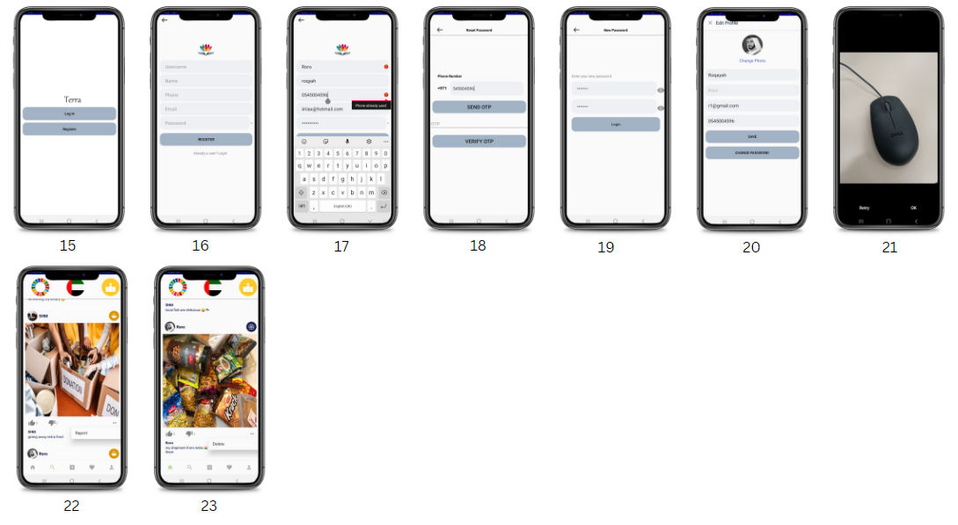 **Appendix C: User interface**

**Figure 13. User Interface**

**Table 23. User interface design description**

|  |  |
| --- | --- |
| **Screen number** | **Description** |
| Screen 15 | User chooses Login or register. |
| Screen 16 | Registration page. |
| Screen 17 | Error message will show that the user entered an existing username or phone number. |
| Screen 18 | Reset password page and OTP verification. |
| Screen 19 | New password page. |
| Screen 20 | Edit profile page. |
| Screen 21 | Page where the user can verify the image or retake a new one |
| Screen 22 | User can report other’s posts |
| Screen 23 | User delete his/her post using the options under the post |